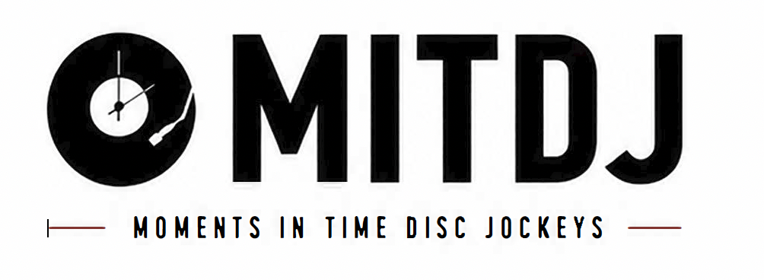 | Email: info@mitdj.com  Website: www.mitdj.com  Phone: 616-334-3110  Mail: PO Box 6346, Grand Rapids, MI 49516
PLEASE FILL OUT FORM AND RETURN TO info@mitdj.com

CUSTOMER INFORMATION:
Name Of Contact:

Email:

Phone:

Address:

EVENT INFORMATION:
Event Type:

Date:
Location:
Number Of Guests:

Start and End Times:

Event Cost:

SELECT YOUR DJ:

$100.00
LEAVE BLANK IF NO SPECIFIC DJ IS REQUESTED
DJ Name:
Request Charge:

ADD-ON FEATURES:
Up-Lighting Cost:

Glow Wand Cost:

Silent Disco Rental:

TERMS AND CONDITIONS
1. A $200.00 non-refundable security deposit is required when booking your event. This deposit is deducted from your total event cost and will show in your invoice statement. In consideration of the payment by the Purchaser as well as the various promises and the agreements set forth below, the Parties agree and intend to be legally bound as follows.

2. Moments In Time Disc Jockeys, LLC shall provide your hours of service as placed in the contract at the location given on the contract.

3. Moments In Time Disc Jockeys, LLC shall be provided and accepted on the following date and time of the engagement as given on the contract.

4. Moments In Time Disc Jockeys, LLC shall, at all times, have unmitigated control of its DJ Services.

5. In the event that additional hours of DJ Services are requested after the finish time this agreement is executed, and Moments In Time Disc Jockeys, LLC accepts said request, additional DJ Services will be charged at the rate of $150.00 per hour, payable the day of the engagement. The parties understand and agree that it may not always be possible to provide additional performance time; Moments In Time Disc Jockeys, LLC is under no obligation to accept an offer to purchase additional hours of DJ Services.

ADDITIONAL TERMS AND CONDITIONS
• The agreement of the DJ to perform is subject to proven detention by accidents, transportation issues, riots, strikes, epidemics, pandemics, any random acts of God, or any other legitimate conditions beyond their control. If such circumstances arise, all reasonable efforts will be made by Moments In Time Disc Jockeys, LLC to make it or find replacement entertainment at the agreed upon fees. Should Moments In Time Disc Jockeys, LLC be unable to procure a replacement, Purchaser shall receive a full refund.

• The Purchaser(s) and DJ servicer agree that this contract is not subject to cancellation unless both parties have agreed to such cancellation in writing. In the event of cancellation by the Purchaser{s) within 60 days of the their event date, the Purchaser(s) shall pay the amount of $300.00 as liquidated damages, plus a reasonable attorney's fee. If the Purchaser(s) cancel the event within 30 days of the set event date, the Purchaser(s) shall pay the DJ servicer the total agreed amount set forth on the contract as liquidated damages, lose their security deposit, plus a reasonable attorney's fee.

• It is understood that if this is a "Rain or Shine" event; Moments In Time Disc Jockeys, LLC' s compensation is in no way affected by inclement weather. For outdoor performances, Purchaser shall provide overhead shelter for setup area. The DJ reserves the right, in good faith, to stop or cancel the performance should the weather pose a potential danger to him, the equipment, or audience. Every effort will be made to continue the performance. However, safety is paramount in all decisions. The DJ's compensation will not be affected by such cancellation.

• Purchaser(s) agree that Moments In Time Disc Jockeys, LLC's liability shall not be liable in any amount of damage which exceeds the performance fees recited above. Further, the Purchaser(s) agree that Moments In Time Disc Jockeys, LLC shall not be liable for indirect or consequential damages arising from any breach of contract.

• In the event of circumstances deemed to present a threat or implied threat of injury or harm Moments In Time Disc Jockeys, LLC staff or any equipment in Moments In Time Disc Jockeys, LLC possession, Moments In Time Disc Jockeys, LLC reserves the right to cease performance. If the Purchaser is able to resolve the threatening situation in a reasonable amount of time (maximum of 1 S minutes), Moments In Time Disc Jockeys, LLC shall resume performance. Purchaser shall be responsible for payment in full, regardless of whether the situation is resolved. Moments In Time Disc Jockeys, LLC reserves the right to deny any guest access to the sound system, music recordings, or other equipment. It is further agreed that the Purchaser shall be liable for any and all injury or damage to the DJ, or property of the DJ, while on the premises of said engagement, if damage is caused by Purchaser or guest, members of his organization, engagement invitees, employees, or any other party in attendance, whether invited or not.

• In the event of non-payment, Moments In lime Disc Jockeys, LLC retains the right to attempt collection through the courts. Purchaser agrees to be held responsible for all court costs, legal fees, and collection costs incurred by Moments In lime Disc Jockeys, LLC.

• By executing this contract as Purchaser, the person executing said contract, personally accepts and assumes full responsibility and liability under the terms of this contract. The laws of the State of Michigan shall govern this agreement. In the event that legal proceedings are initiated by either party, it is agreed that proper venue shall be in Kent County.

• Purchaser{s) agree to indemnify, defend, assume liability for and hold Moments In Time Disc Jockeys, LLC's harmless from any claims, damages, losses and expenses by or to any person, regardless of the basis, which pertains directly or indirectly to Moments In lime Disc Jockeys, LLC performance.

• THE PARTIES acknowledge that they have read the above Agreement in its entirety, understand all of its terms and conditions, have had an opportunity to review the same with legal counsel, and agree to abide by the terms of this agreement of his/her own free will and consent.

BY TYPING, YOU ARE SIGNING
Agreed: |  | Date:
Client Name

Agreed: Date:

MITDJ Name

