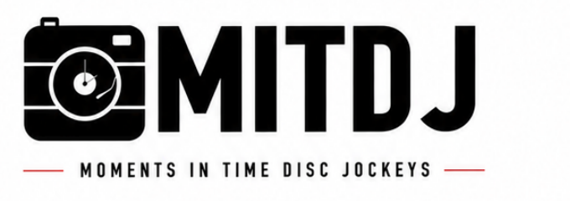 | Email: info@mitdj.com  Website: www.mitdj.com  Phone: 616-334-3110  Mail: PO Box 6346, Grand Rapids, MI 49516
PLEASE FILL OUT FORM AND RETURN TO info@mitdj.com
CUSTOMER INFORMATION:
Name Of Contact:
Email:

Phone:
Address:
EVENT INFORMATION:
Event Type:
Date:
Location:
Number Of Guests:
Start and End Times:

Type Of Booth: | Hybrid Social Photobooth 360 Photobooth
Photobooth Cost:
TERMS AND CONDITIONS
- A $200.00 non-refundable security deposit is required when booking your event. This deposit is deducted from your total event cost and will show in your invoice statement. In consideration of the payment by the Purchaser as well as the various promises and the agreements set forth below, the Parties agree and intend to be legally bound as follows.

- MITDJ Photobooths, LLC shall provide your hours of service as placed in the contract at the location given on the contract.

- MITDJ Photobooths, LLC shall be provided and accepted on the following date and time of the engagement as given on the contract.

- MITDJ Photobooths, LLC shall, at all times, have unmitigated control of its Photobooth Services.

- In the event that additional hours of Photobooth Services are requested after the finish time this agreement is executed, and MITDJ Photobooths, LLC accepts said request, additional Photobooth Services will be charged at the rate of $250.00 per hour, payable the day of the engagement. The parties understand and agree that it may not always be possible to provide additional performance time; MITDJ Photobooths, LLC is under no obligation to accept an offer to purchase additional hours of Photobooth Services.

ADDITIONAL TERMS AND CONDITIONS
- The agreement of the photobooth to perform is subject to proven detention by accidents, transportation issues, riots, strikes, epidemics, pandemics, any random acts of God, or any other legitimate conditions beyond their control. If such circumstances arise, all reasonable efforts will be made by MITDJ Photobooths, LLC to make it to the event or find a photobooth replacement at the agreed upon fees. Should MITDJ Photobooths, LLC be unable to procure a replacement, Purchaser shall receive a full refund.
- The Purchaser(s) and photobooth servicer agree that this contract is not subject to cancellation unless both parties have agreed to such cancellation in writing. In the event of cancellation by the Purchaser(s) within 60 days of the event date, the Purchaser(s) shall pay $300.00 as liquidated damages plus reasonable attorney's fees. If cancelled within 30 days, the total agreed amount shall be due and the security deposit forfeited.
- It is understood that if this is a 'Rain or Shine' event, MITDJ Photobooths, LLC compensation is not affected by inclement weather. Outdoor performances require overhead shelter. Safety is paramount and services may be stopped if conditions become dangerous.
- Purchaser(s) agree that MITDJ Photobooths, LLC liability shall not exceed the photobooth fees and shall not be liable for indirect or consequential damages.
- In the event of circumstances presenting a threat or implied threat of injury or harm, MITDJ Photobooths, LLC reserves the right to cease operation until the situation is resolved. Purchaser is responsible for payment in full and for damages caused by guests or attendees.
- In the event of non-payment, MITDJ Photobooths, LLC retains the right to attempt collection through the courts. Purchaser agrees to be responsible for all court costs, legal fees and collection costs.
- By executing this contract, the Purchaser accepts full responsibility and liability under these terms. Michigan law governs this agreement and venue shall be Kent County.
- Purchaser(s) agree to indemnify and hold harmless MITDJ Photobooths, LLC from claims, damages, losses and expenses arising from photobooth operation.
- The parties acknowledge they have read and understand this agreement and agree to abide by its terms.

BY TYPING, YOU ARE SIGNING
Agreed: |  | Date:
Client Name  Agreed:  MITDJ Photobooth Name |  | Date:

